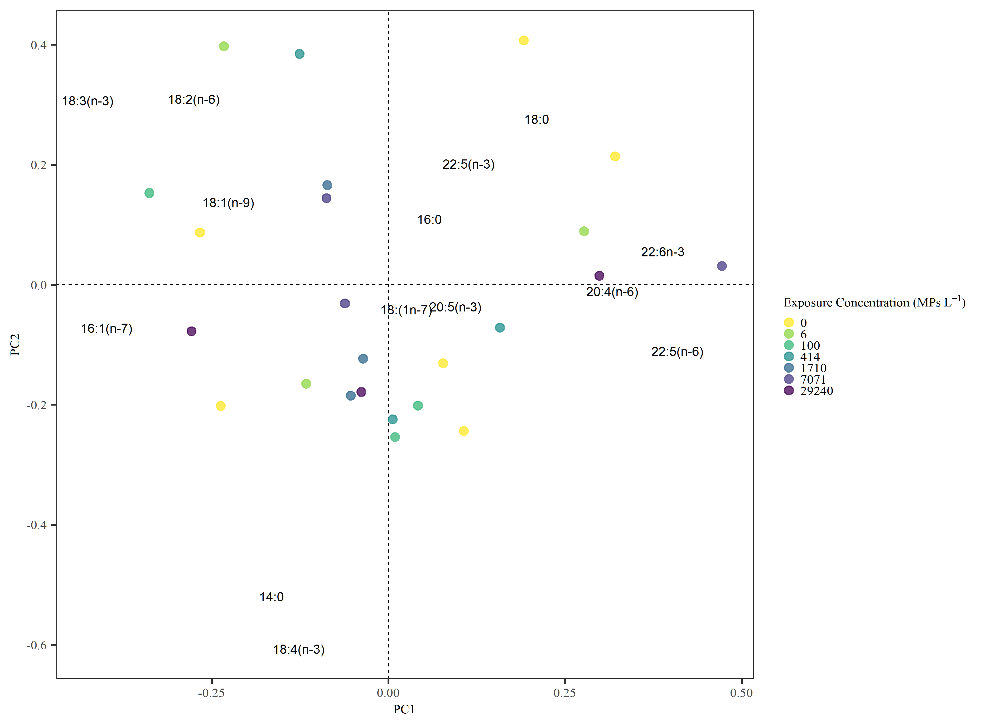

PCA and RDA using centred log-ratios for fatty acids, excluding those below 1% composition. No significant effect of treatment on FA according to pseudo-F-test (F­6,17 = 0.41, p = 0.97).

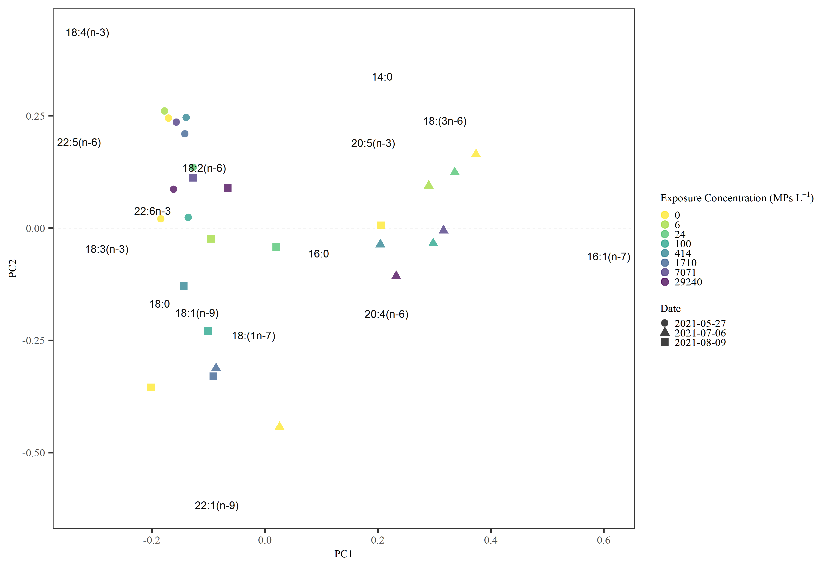

PCA and RDA using centred log-ratios for fatty acids, excluding those below 1% composition. No significant effect of treatment on FA according to pseudo-F-test (F­17,24 = 0.71, p = 0.72), but significant effect of date (F­17,19 = 16.78, p < 0.001).

Initial zooplankton higher than midpoint in 18:4(n-3), a marker of dinoflagellates. Midpoint higher than initial and endpoints in 16:1(n-7), which is abundant in diatoms. Endpoint zooplankton higher than initial point in 22:1(n-9), a MUFA, and lower in 18:4(n-3). Start and endpoints both higher than midpoint in 18:3(n-3), a DHA precursor, and lower in 18:3(n-6), an ARA precursor.